PANDIT DEENDAYAL ENERGY UNIVERSITY SCHOOL OF TECHNOLOGY

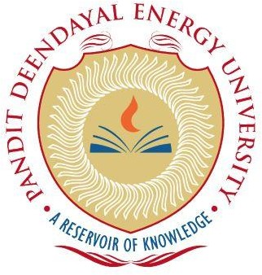

Course: **Artificial Intelligence Lab**

“Kidney Normal, Stone, Cyst and Tumor,”

PROJECT REPORT

B.Tech. (Computer Science and Engineering)

Semester 6

**Submitted By:**

Chintan Udani 20BCP301D

Harsh Joshi 20BCP314D

Div-1 (G2 batch)